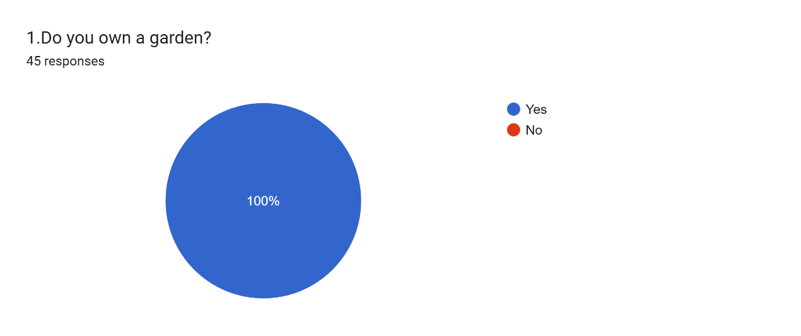

Forms response chart. Question title: 2.How satisfied are you with your current garden? (1 being very dissatisfied, 5 being very satisfied)  
. Number of responses: 45 responses.

Forms response chart. Question title: 3  How often do you spend time in your garden?  
. Number of responses: 45 responses.

Forms response chart. Question title:   4. Have you made any changes or improvements to your garden in the past year?
. Number of responses: 45 responses.

Forms response chart. Question title: 5.If you were to make changes to your garden, what would you focus on? (Select all that apply)
. Number of responses: 45 responses.

Forms response chart. Question title: 6 Where do you usually look for inspiration or advice when it comes to garden improvements?

. Number of responses: 45 responses.

Forms response chart. Question title:   7 How often do you perform maintenance tasks in your garden (watering, pruning, etc.)?  
. Number of responses: 45 responses.

Forms response chart. Question title: 8 Which maintenance tasks do you find most challenging or easy to forget? 
. Number of responses: 45 responses.

Forms response chart. Question title: 9 If a website could generate design ideas for your garden based on a photo, would that be interesting to you?
. Number of responses: 44 responses.

Forms response chart. Question title: 10 What do you think about the current layout of your garden?
. Number of responses: 45 responses.

Forms response chart. Question title: 11 What aspect of your garden do you find least appealing?
. Number of responses: 45 responses.

Forms response chart. Question title:   12 . Would you be interested in a feature that helps you keep track of garden maintenance tasks?
. Number of responses: 45 responses.

People have a strong demand for garden design and beautification: In the survey, a considerable number of respondents expressed interest in improving their garden design. In particular, when asked, "Would you find it interesting if a website could generate garden design ideas based on a photo?" 36.4% responded positively, and another 43.2% said they would like to learn more about it. This indicates that they are interested in innovative garden designs.

People prefer to get garden design inspiration from the internet and social media: In response to the question, "Where do you usually look for inspiration or advice when it comes to garden improvements?" 40% of people chose online blogs, social media platforms, etc., as their primary sources of inspiration. In contrast, only 20% would seek help from professional designers. This highlights the importance of online platforms as a reference for design ideas.

People place more importance on engagement and a sense of accomplishment when designing their gardens, rather than just the design format: While many people express a need for design, feedback from the survey shows that some users focus more on personal involvement and a sense of achievement during the design process, such as "real-time browsing and interactive feedback." This suggests that future garden design tools could consider adding more interactive features, allowing users to see design outcomes in real-time and make adjustments accordingly.

Link：

<https://docs.google.com/forms/d/e/1FAIpQLSdbti3waLUeFtzZi4SDZzB20sS8oieRDfZIaPlE4FS1oQygHQ/viewform?usp=sf_link>